Public Welcome

# O h i o F a l c o n r y A s s o c i a t i o n

***A n n u a l E n d o f T h e S e a s o n M e e t***

## Where: 421 East Main St (SR 331)

***Holloway Ohio (Belmont County)***

***@ Oldtimer’s Building***

***Look for Red Caboose***

Directions take 70 W to Belmont Tech exit 213 and make Rt onto SR 331 N then go about

10 miles into Flushing. At "T" (Stop Sign) take Rt downhill (Still on RT 331) to Holloway for 4 more miles. Look for Red Caboose on Rt!!

***When: MARCH 7th, 8th, & 9th Early***

***Morning to Dusk***

***Come go rabbit/squirrel hunting with us and the hawks and meet some great Falconers.* See a variety of raptors hit the woods for a few days of hunting and excitement. This is an opportunity to explore any interest in the pursuit of Falconry, ask questions, probe people’s minds, build relationships and make new friends. It is an amazing experience. Heated building to stay overnight bring cot or sleeping bags. Plenty of food & water will be available.**

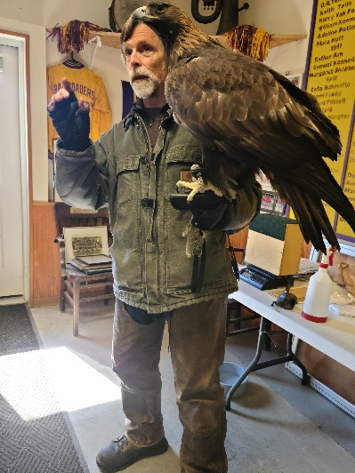**We hope to see a lot of new faces this year as we did last year. For more details please contact Mick Brown, OFA President @ 740-359-1341.**

